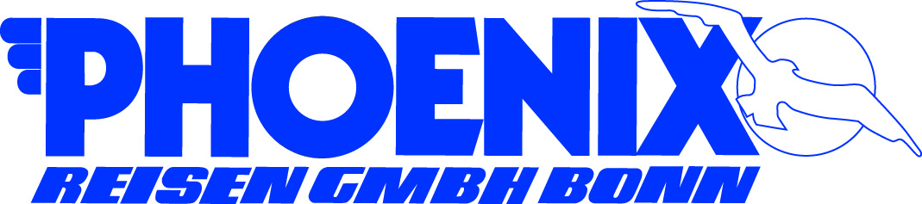**PORT QUESTIONNAIRE**

|  |  |  |  |
| --- | --- | --- | --- |
| Port: | BALTIMORE | Arrival Time: | 9:00 |
| Ship: | AMADEA | Departure Time: | 18:00 |
| Date: | April 19, 2018 | Public Holiday: | NO |
| **Name & Address of Port** | | **Name/No. of expected Berth** | |
| BERTH 10 – same as last year with Amadea | | Berth 9 | |
| 2001 East McComas Street,  Baltimore, MD 21230 | | I contacted port agent and it seems that the ship is confirmed at cruise terminal | |

|  |  |  |  |  |  |  |
| --- | --- | --- | --- | --- | --- | --- |
| PORT FACILITIES | Y | Bank | Y | Post | Y | Tourist Info |
| *(Please mark with Y or N)* | Y | Telephone | Y | Internet | Y | Taxi (on street) |

|  |  |  |
| --- | --- | --- |
| Telephone Country Code and City Code | Dial out code to Germany: | Postage fee to Germany  (postcard / letter) |
| 00 1 (410), (443), (667) | 011 49 | USD $ 1.15 |
| Local Time (GMT +/- hrs) | Languages | Crime Rate |
| +6 Hours | ENGLISH | Low in City Center |
| Temperature | Humidity | Recommended Clothing |
| average: high 19C./ low 9C. | 59% | Warm Jacket, sweater |

|  |  |  |  |  |  |  |  |
| --- | --- | --- | --- | --- | --- | --- | --- |
| Nearest Bank/ Exchange Office | Banking Hrs. | | Currency | | € 1 = | US$ 1 = | |
| Bank of America  100 S Charles St. | 9:00 – 17:00 | | USD | | EUR 1.00 | USD 1.18 as of July 2017 | |
| Accepted Payments | Y | Only local currency | | Y | Cash in US$ |  | Cash in € |
| *(Please mark with Y or N)* | Y | Credit Cards (please specify): Master Card, Visa Card, American Express, some Diners Club. | | | | | |
|  | N | Maestro/Debit Card | | | | | |

|  |  |  |  |  |
| --- | --- | --- | --- | --- |
|  | City Center | Beach | Airport | Main Station |
| Name of: | Inner Harbour | N/A | BHB | n/a |
| Distance in km to: | 900m |  | 17 km |  |
| Taxi fare to: | $ 10 |  | $35 |  |

|  |  |  |
| --- | --- | --- |
|  | Where: | Business/Opening Hours: |
| Tourist Information | 401 Light St Baltimore, MD 21202 | 8:30 – 17:30 |
| Post Office | 111 N Calvert St | 9:30 – 14:00  15 – 17:00 |
| Internet Café | N/A but all major restaurants / fast food chains offer free WiFi – Starbucks 200 East Pratt Street (450 m) | Starbucks hours:  Sunday: 9 AM – 6:30 PM  Monday: 7 AM – 9 PM |
| Shopping | Main Street – downtown Bar Harbor  boutiques | 9 :00 – 21:00 |
| Museums | Ripley’s Believe it or Not, American Visionary Art Museum, USS Constellation, Maryland Science Center, Star-Spangled Banner Flag House, National Aquarium | 9:00 – 17:00 |
| Restaurants | Bubba Gump Shrimp Co., Morton’s Steakhouse, Bistro 300, Kona Grill, Cheescake Factory, M&S Grill, Hard Rock Cafe, Brio Tuscan Grill | 11 :30 – 22 :00 |
| Places of interest: | Federal Hill Park, Museums, National Aquarium, USS Constellation, Fort McHenry |  |

|  |  |  |  |  |  |  |
| --- | --- | --- | --- | --- | --- | --- |
| Shore leave for pax… *(Please mark with Y or N)* | Y | …with Landing Card | Y | with Passport  recommended | N | Customs & immigration |

|  |  |
| --- | --- |
| Typical Souvenirs: | Post cards, art crafts, Baltimore Ravens jerseys and memorabilia |
| Special Remarks: | The west wall of the inner harbor is in the middle of the city center and walking distance to most restaurants and shopping is 5-15 min. The inner harbor is a historic seaport that has been turned into a tourist attraction. Baltimore is one of the East Coast's most popular vacation destinations and most famously known as the city where Francis Scott Key wrote the lyrics for the Star Spangled Banner. Walking on their own to explore the city center and inner harbor will be safe and fine. |